NAME : Sethu pathi.R

DEGREE : B.Sc

BRANCH : Computer Science

COLLEGE : Nachiappa swamigal arts and science college-koviloor.

FATHER’S NAME : Ramamoorthy.P

DATE OF BRITH : 12/08/2003
GENDER : Male

LANGUAGES KNOWN :
Read - Tamil & English

Speak - Tamil & English

Write -Tamil & English

EMAIL :sp12082003@gmail.com

MOBILE : 9384341854

PERMANENT ADDRESS : :374/5,Thevar street, Kongarathi, kandaramanickam (post), Thiruppathur (Taluk),Sivaganga district

ACADEMIC RECORD

COURSE | Institution | Board/  University | CompletionBy | Marks(%)  CGPA
B.Sc | Nachiappa swamigal arts and science college | Alagappa University | _ | _
XII | Sethu irani matriculation higher secondary school | State Board | 2021 | 82%
X | Sethu irani matriculation higher secondary school | State Board | 2019 | 76%

SKILL SET
- Proficient in Python Programming
- Expertise in Ambiance and Design Strategies
- Strong Event Management Capabilities
- Demonstrated Leadership Skills

HOBBIES
- Art and Painting Enthusiast
- Avid Reader
- Freelance Interior Designer

EXTRACURRICULAR ACTIVITIES
- Fine Arts Club: Served as a dedicated member
- CAP and Nature: Active participation in environmental initiatives
- Hostel Floor Representative: Provided exceptional service and support
- Engaged in various Drawing and Painting Competitions showcasing talent

DECLARATION
I R.Sethu pathi do here by confirm that the information given above is true to the best of my knowledge.
Place : Koviloor
Date : 26/10/2023
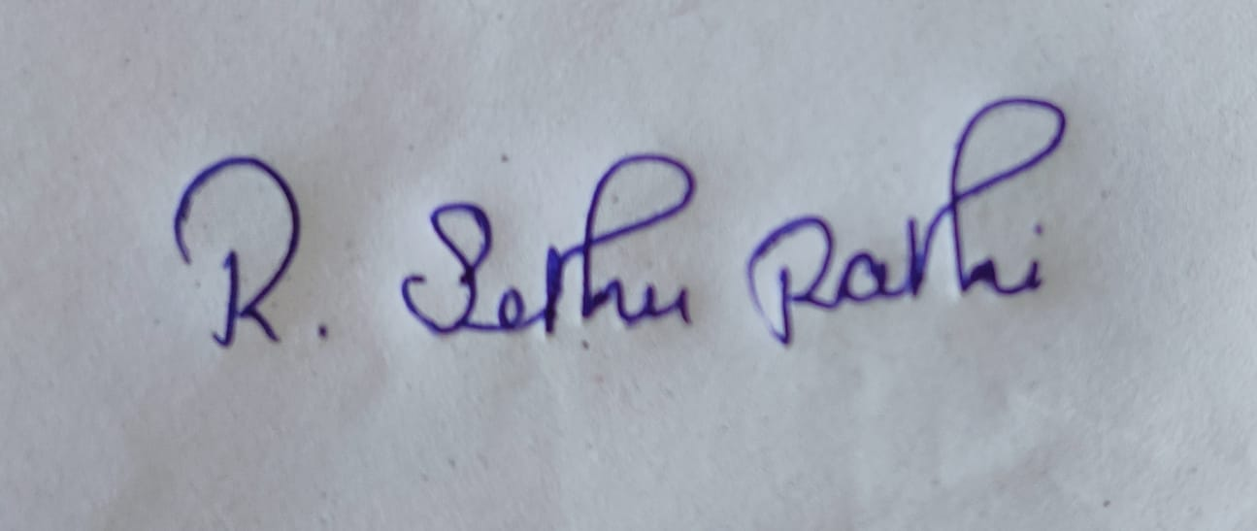

R.Sethu pathi

